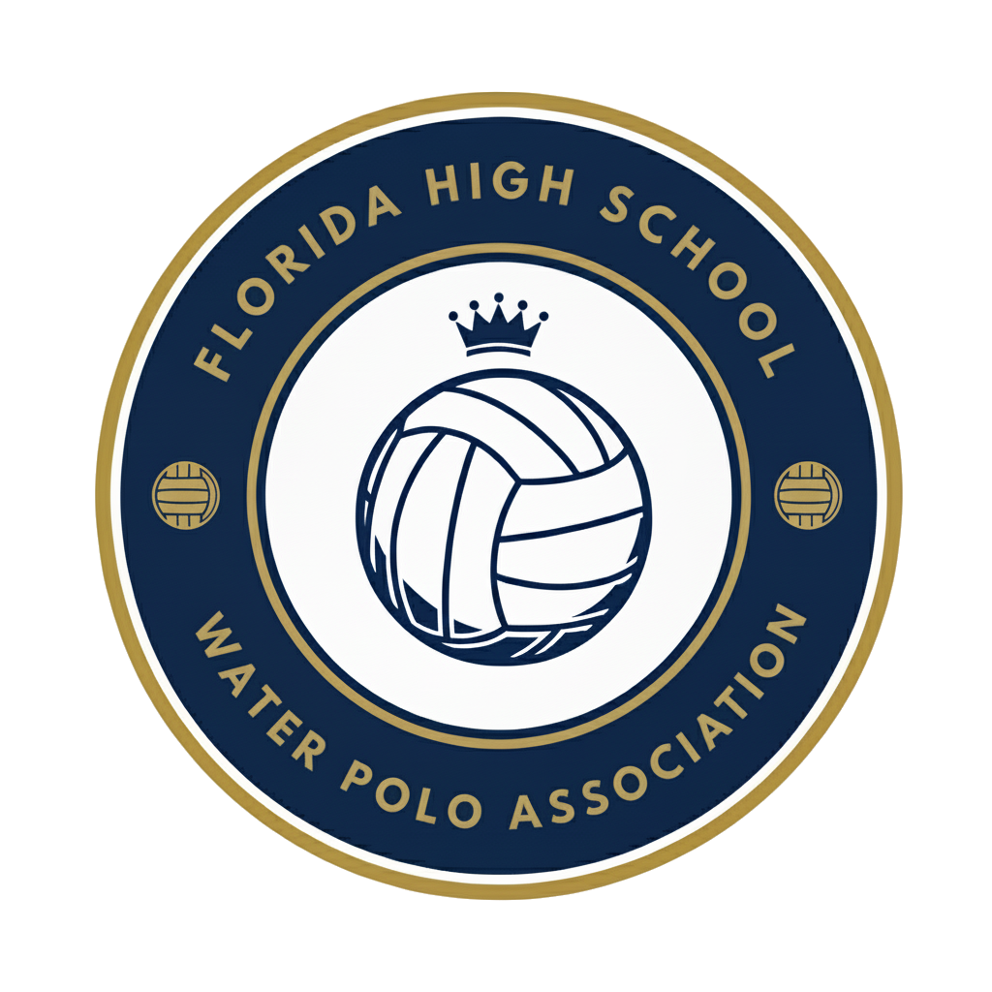
FHSWPA COACH LEADERSHIP GROUP
Sunday, October 26th at 6:30 pm
Meeting Notes
Quick recap
The meeting focused on discussing the status and expansion of water polo programs across Florida, including efforts to establish new high school teams and coordinate with USA Water Polo and CWPA organizations. The group explored strategies for growing the sport through coach education clinics, parent engagement, and the development of new competitive opportunities, while addressing challenges related to funding, pool time allocation, and administrative resistance. Various regional initiatives were discussed, including plans for new programs in Gainesville, Tallahassee, Jacksonville, and the West Florida region, with emphasis placed on leveraging existing swim programs and club athletes to drive expansion.

Summary

Executive Board and Water Polo Update
Joe began introducing the agenda and introduced the Executive Board members for the FHSWPA, including Stephanie, Kurt, and Mike Schofield as well as Frank Quesada, who is a U.S.A. Water Polo board member. Frank shared his background in water polo and his role on the board, emphasizing his experience and commitment to the sport.

Florida Water Polo Development Challenges
Frank discussed the challenges facing Florida water polo, including funding, coaching support, pool time allocation, and administrative resistance. He highlighted the need for better communication and coordination between USA Water Polo and CWPA, as well as the creation of a centralized platform, FLWaterpole.com, to facilitate information sharing and community engagement. Frank also mentioned ongoing efforts to secure support from the FHSAA and the potential for recruiting college-level referees and coaches to enhance the sport's development in Florida.

USA Water Polo Southeast Integration
The meeting focused on integrating efforts to promote USA Water Polo and discussing the new Southeast Zone website, which Zak suggested could include existing work and programs. Frank, as a USA Water Polo Board member, agreed to integrate the two platforms, emphasizing the importance of collaboration. Joe discussed the Florida High School Water Polo Association's primary goal of growing the sport at the high school level, introducing a coach leadership track to enhance communication and organization. Marko suggested using a dedicated email address for the organization to increase credibility and engagement, and Joe agreed to explore this option while emphasizing the need for local contacts to drive initiatives.

Coaches Meeting and Program Planning
The group decided to schedule the next all-coaches meeting for Sunday, November 16th at 6:30 PM, after determining that other dates would conflict with ODP camp, Carifta, and Masters tournament events. They discussed plans to create PDF guides and contact lists for both coaches and referees, with the goal of expanding the pool of available officials and coaches, particularly for new high school water polo programs. The coaches agreed to continue holding parent meetings and follow up with parents who expressed interest through a Google Form, with a focus on engaging parents who want their children to play on high school teams.

Florida Water Polo Program Expansion
The group discussed strategies for expanding high school water polo programs in Florida, focusing on targeting schools with existing swim teams and club athletes who want to play high school water polo. They agreed to create a Google Form to collect information on potential new schools, with Joe promising to maintain an updated list of prospective schools. Frank announced that USA Water Polo would be providing educational materials for swim coaches on the benefits of starting water polo programs. The group also discussed the importance of using appropriate terminology when discussing new programs with athletic directors, with David advising against using the term "club water polo" in favor of "FHSAA team."

Water Polo Expansion Strategy Meeting
Dave explained their strategy to expand water polo in Gainesville by targeting 4-5 schools to establish new programs, leveraging USA Water Polo and FHSAA support. They aim to recruit 10 students per school to start co-ed teams, with the goal of having 3-5 schools participate. The initiative relies on parental and student advocacy, as well as cooperation from principals who hold the power to hire coaches. Dave noted that sharing pool facilities between is common and should not be an issue for the proposed expansion.

Florida Water Polo Program Development
The group discussed the challenges and opportunities for growing water polo programs in Florida, focusing on recruiting athletes from other sports, managing pool time, and organizing local competitions. They agreed on a plan to host three Saturday play dates at local pools for the first year, promoting rivalries and increasing opportunities for schools to compete. Adam shared his efforts to start new teams in Tallahassee and Pensacola, emphasizing the importance of college club teams' involvement and the need for novice team tournaments to build success and retention. Joe suggested organizing local championships for new areas in late March to help them build momentum.

Youth Water Polo Coach Education
The group discussed expanding youth water polo programs into high schools, with Manny reporting progress at private schools including St. John's Country Day and connections with Providence and Episcopal. They agreed to hold in-person coach education clinics in Orlando on December 11th and during holiday camps, with Mike Schofield organizing MLK weekend clinics in Boca. The group decided to present a menu of coach education opportunities at the November 16th meeting, including both online and in-person options, with a focus on providing content as early as possible in December to help new coaches prepare for the high school season. They scheduled their next meeting for Sunday, December 7th.

Water Polo Expansion and Initiatives
The group discussed several water polo initiatives, including plans for MLK Weekend and ODP tournaments, with Carlos confirming the return of a successful tournament. Tina shared positive developments from a swimming event, where she connected with two women interested in starting Splashball programs in Fort Lauderdale and Miami. The team also discussed potential expansion efforts in Tallahassee and Florida's Gulf Coast region, with Marko reporting progress in contacting Sarasota County's superintendent about water polo programs at Venice High School and other schools.

